**Use the “HR” database (Database file is present in \\fs\lectures$), write down following SQL**

**queries**.

1. Insert a new job with the following information

a. Job id is “P_PROG”

b. Job title is “Python Programmer”

c. Min Salary is 60000

d. Max Salary is 100000





2. Update the name of Department whose department_id is 60, the new name is Information

Technology.

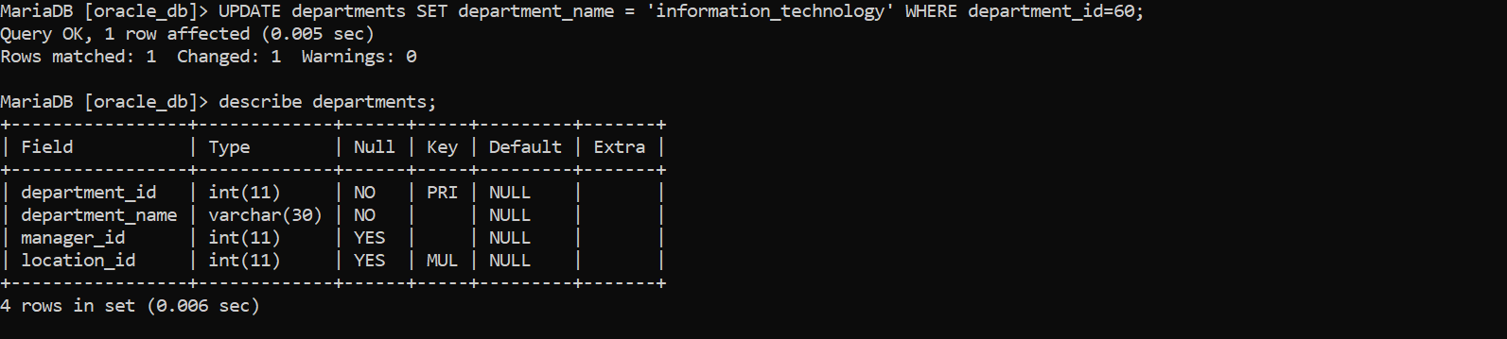

3. Update the minimum and maximum salary of the above inserted record, the new Minimum

salary is 20,000 and max salary is 40,000.

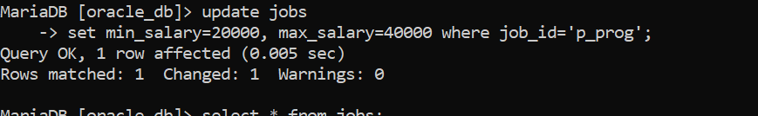



4. Add 5000 to maximum salary of all jobs whose id is FI_MGR.







5. Delete the inserted new record of location table.

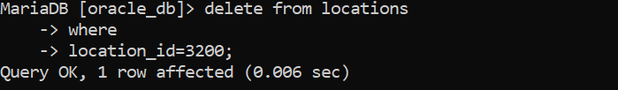

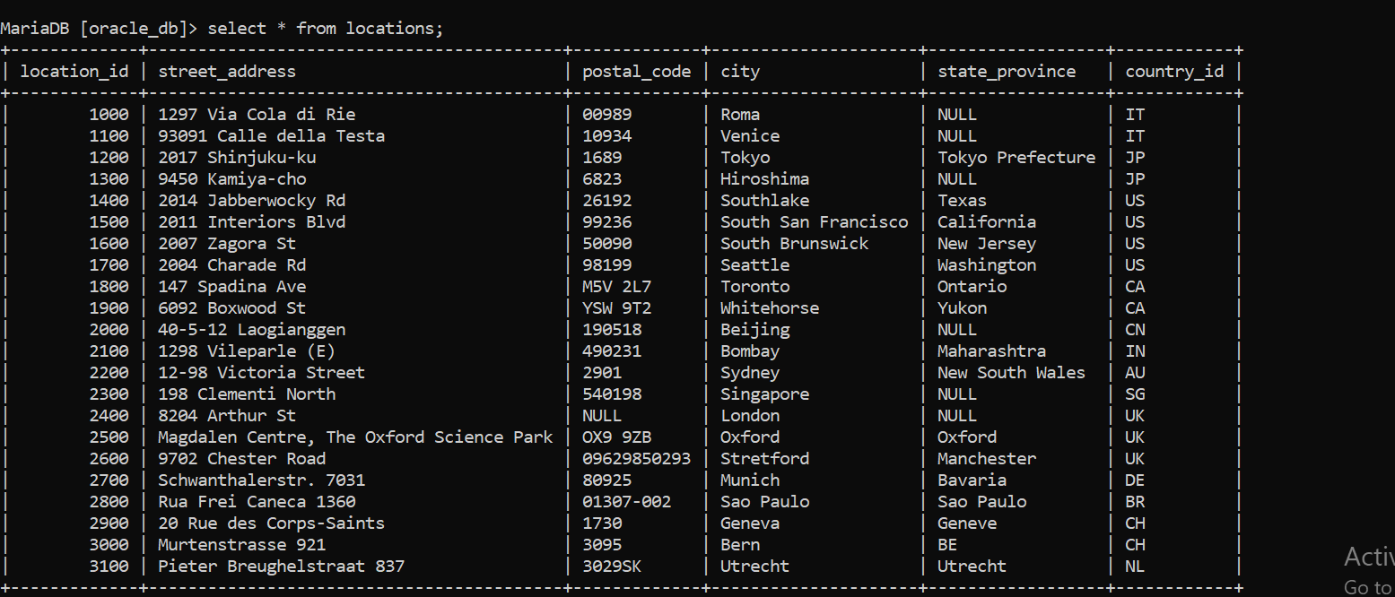

6. Select all the records of Countries table.

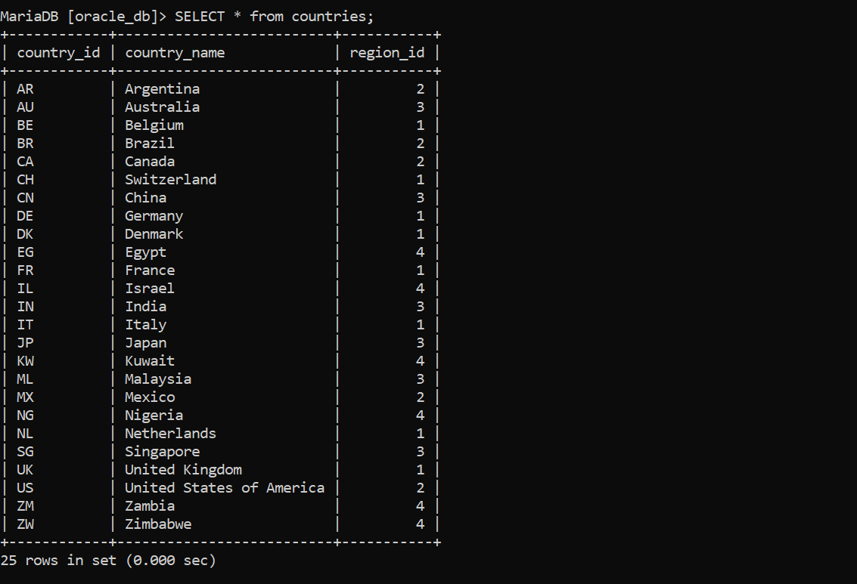

7. Select all the records of job_history table.

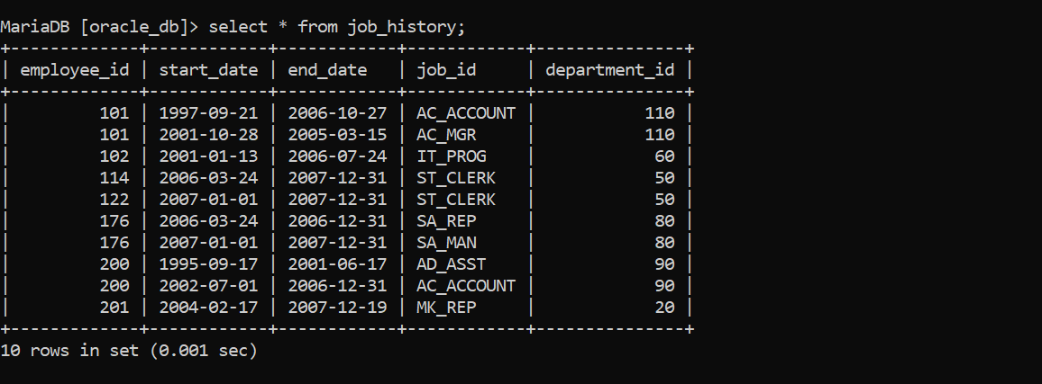

8. Select all the records of regions table.

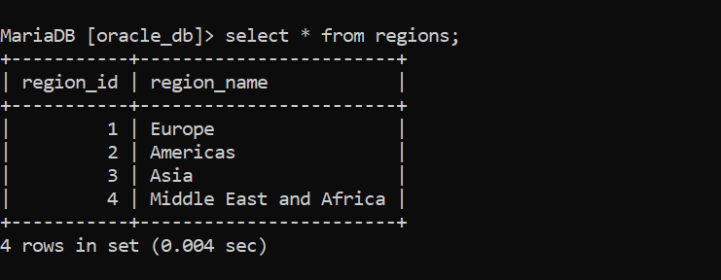

9. Select location_id and streetaddress of location table.

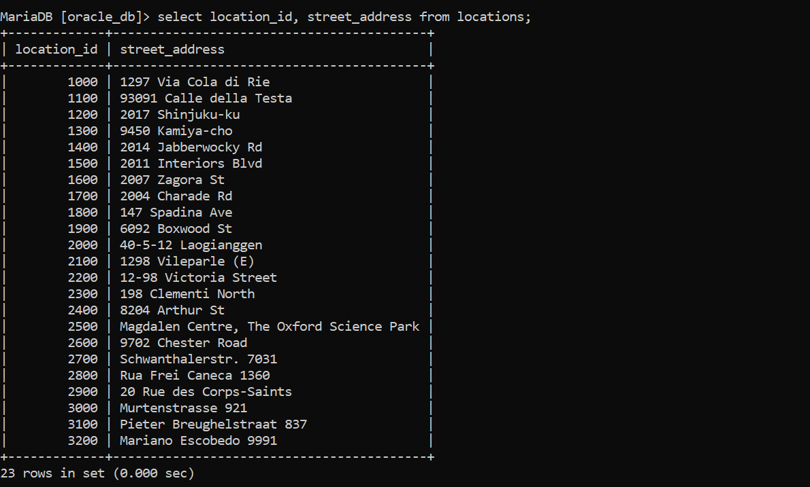

10. Show all employees whose job_id is IT_PROG.



11. Show all location information including location_id, street_address etc of US country.

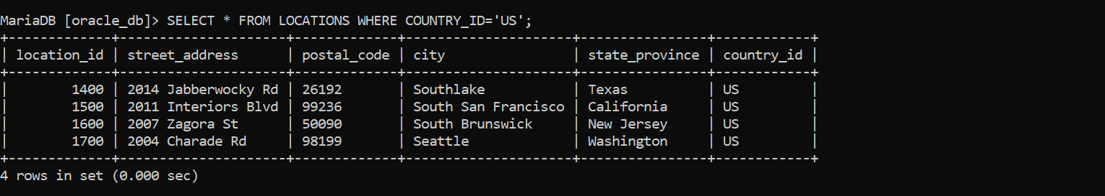

12. Show first_name, last_name, email of employee whose job_id is FI_MGR.

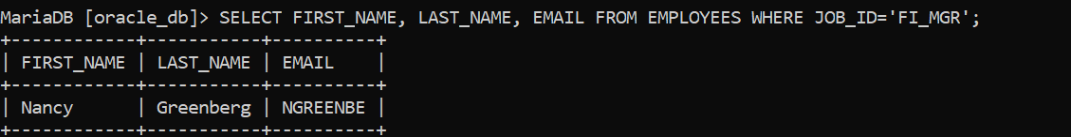

----( UN-SEEN TASK)---

UFT-2

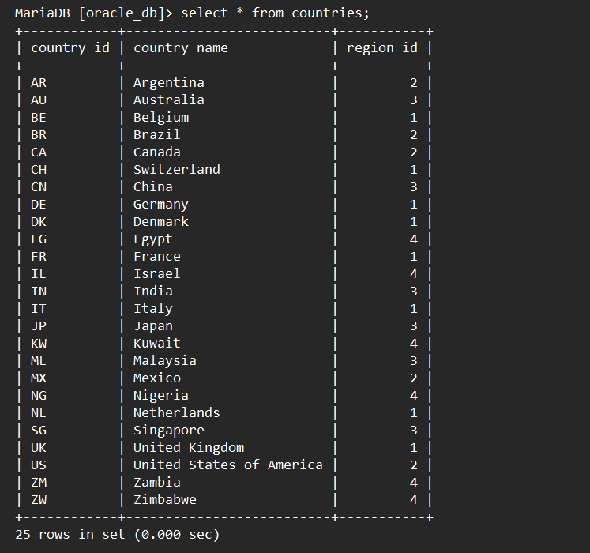

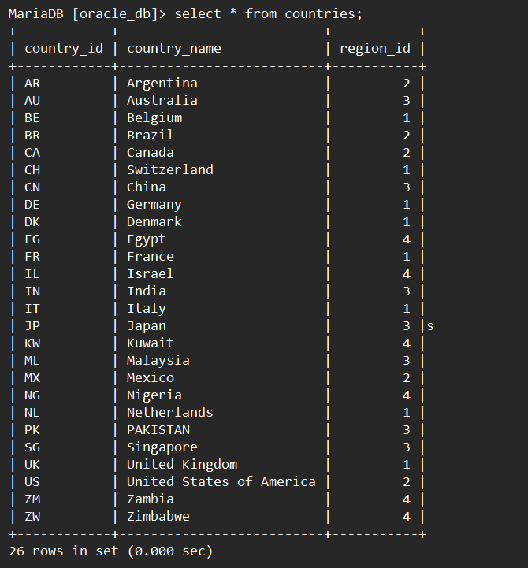



UTF-1

